X 22. Biological Evolution: A History of Ideas *(RHM: Chapter 01, 20)*

______________________________________________________________________________

I. Scientific Method *(14-21)*

A. How we support belief systems

B. The Scientific Method

1. Logical Form

2. Hypotheses

3. Implicit assumptions

C. The Scientific Method and the Study of Evolution

II. Pre‑Darwinian Conceptions of the Natural World *(457-460)*

A. Ideal Types

B. Creationist Thought

1. Ideas and implications

2. The Scala Naturae

3. Role of Science in the 17th and 18th centuries

4. 18th century advances: Buffon and Cuvier

C. Early Evolutionary Thought

1. Advances in geology

2. Early evolutionists

III. 19th Century Evolutionary Theory *(460-465)*

A. Fundamental Concepts of Darwin's Theory

1. Competition

2. Heredity and Fitness

3. Generation of variation

B. Missing Evidence

C. Theory of Evolution by Natural Selection

1. Materialistic

2. Population‑level thinking

3. Multi‑factor process

IV. Modern Evolutionary Theory *(465-473)*

A. The Modern Synthesis

B. Microevolution vs Macroevolution

1. morphological novelties

2. evolutionary developmental biology

C. Misconceptions and social abuses

V. Evolution as the Unifying Theory of Biology

22-1

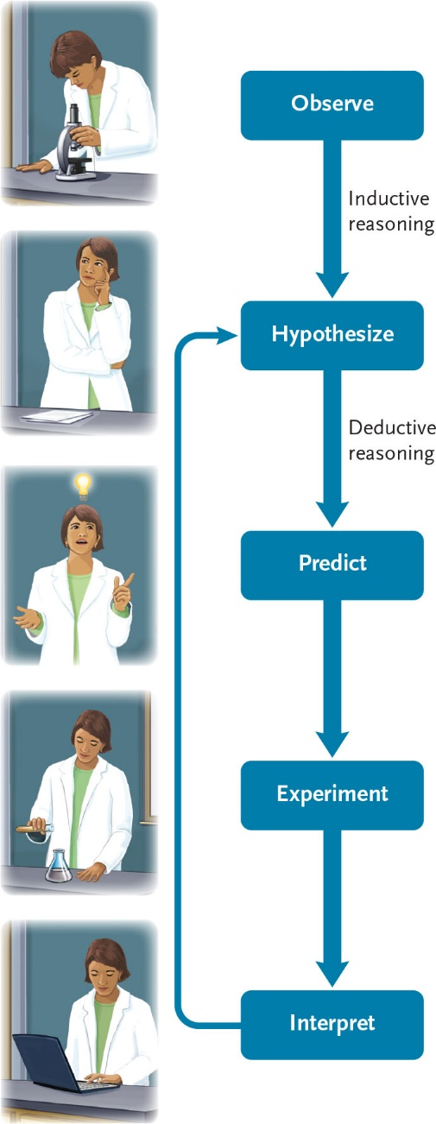

22-2

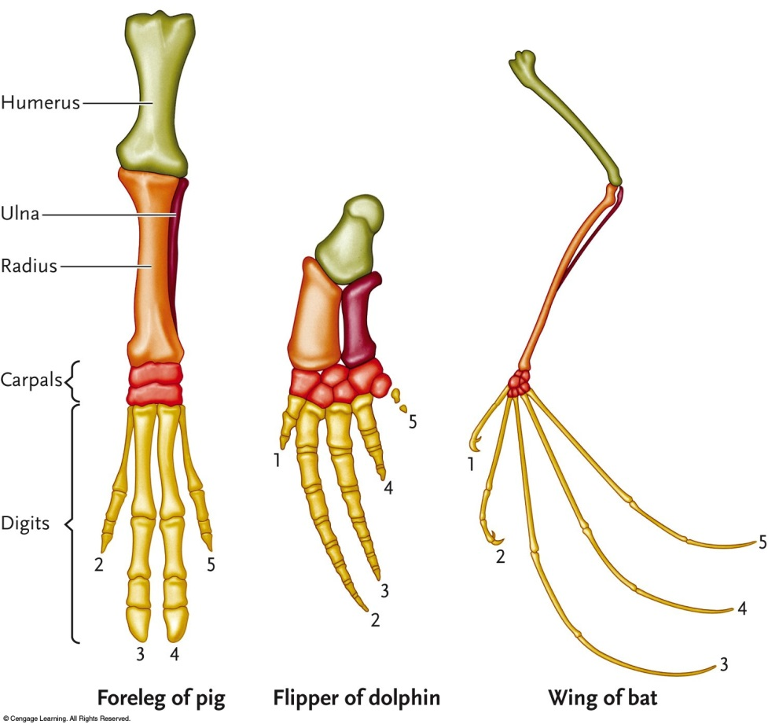

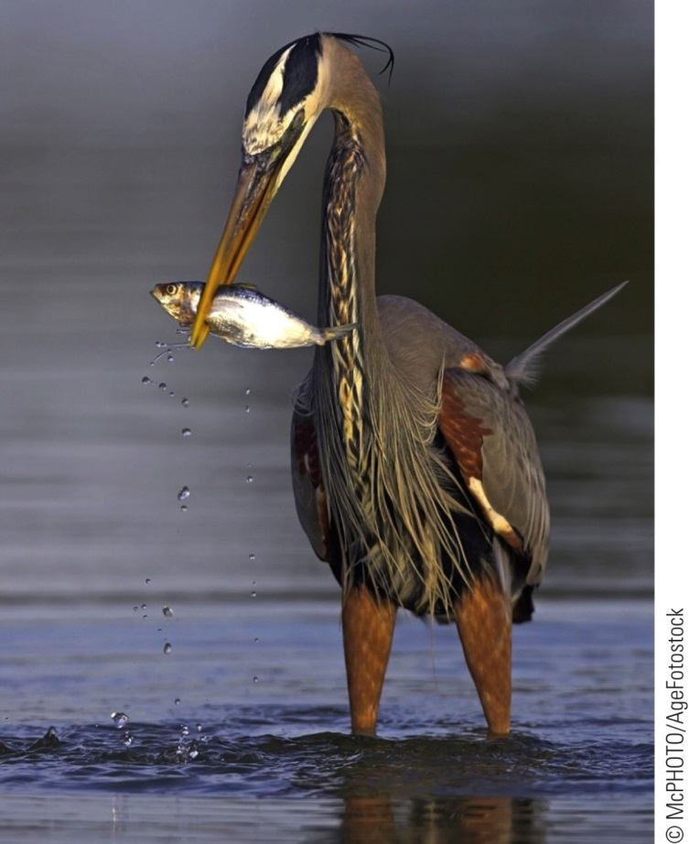

22-3





